Nama : Gerson Wissaluno

Nim : 11201034

Matakuliah : Sister Terdistribusi B

Kode FROM Instruction

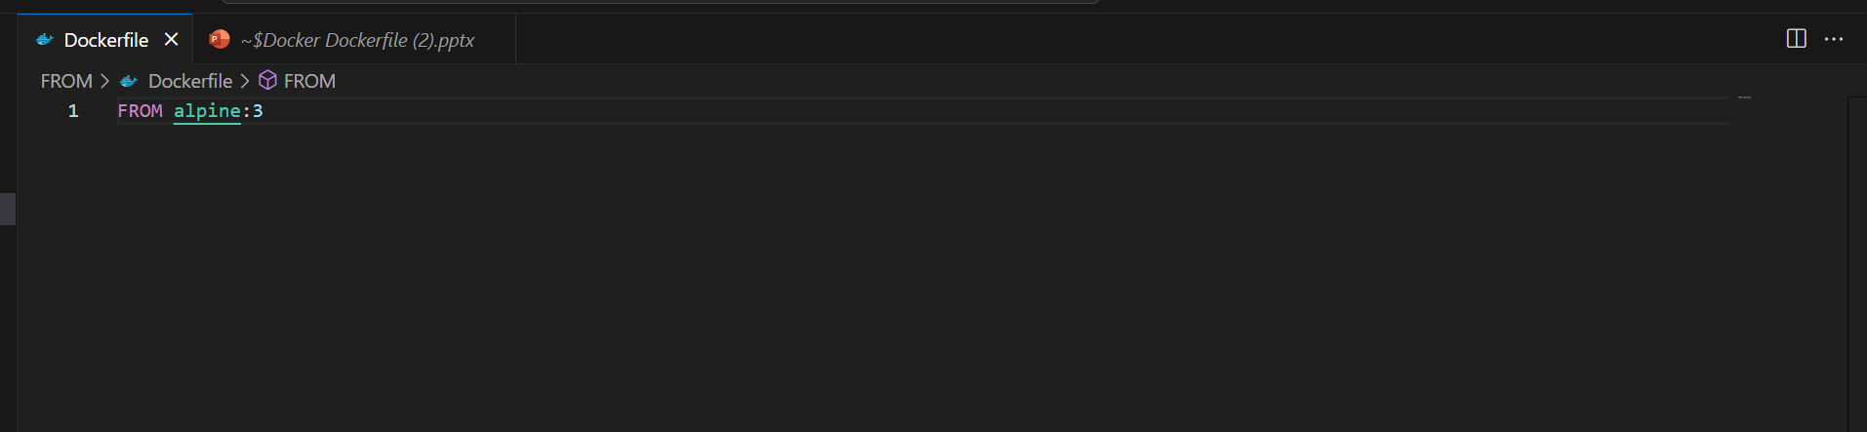

Kode : Docker Build

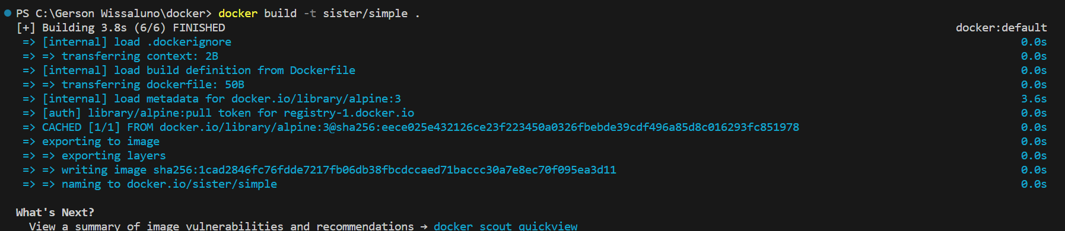

Kode Run Instruction

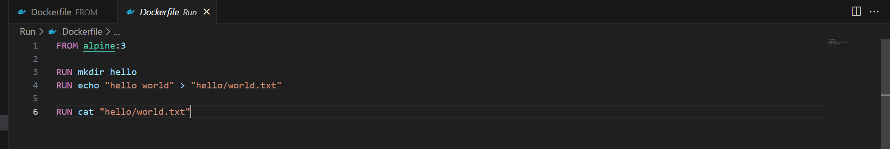

Kode : Docker Build

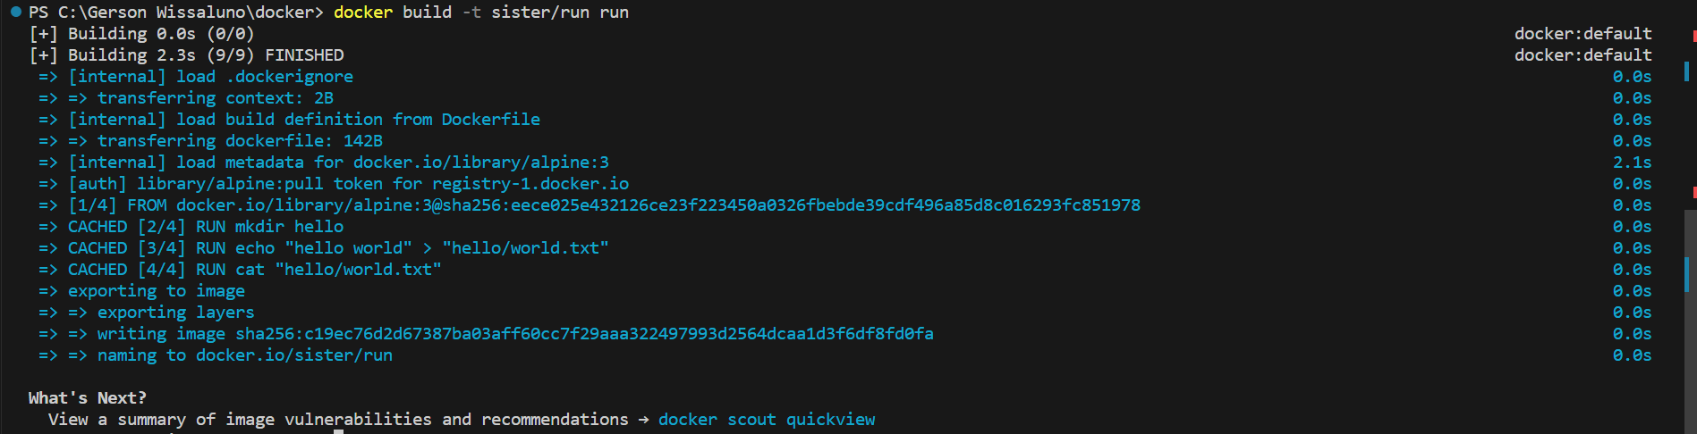

Kode Command Instruction

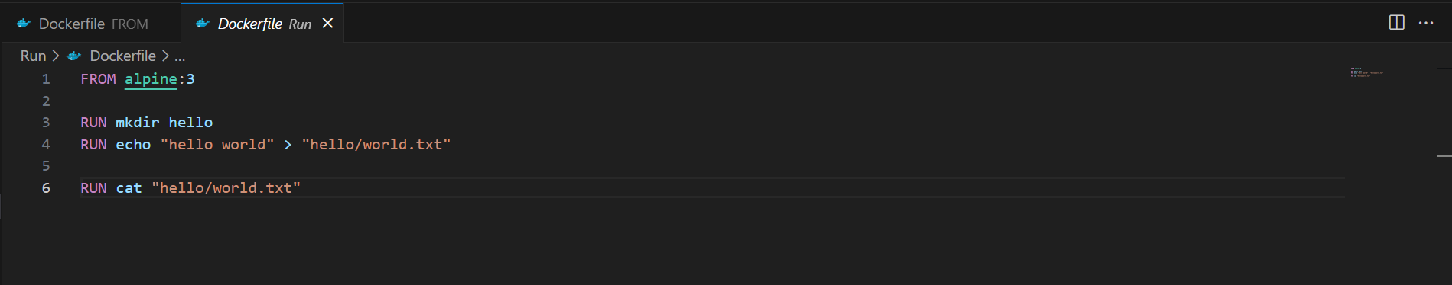

Kode : Docker Build

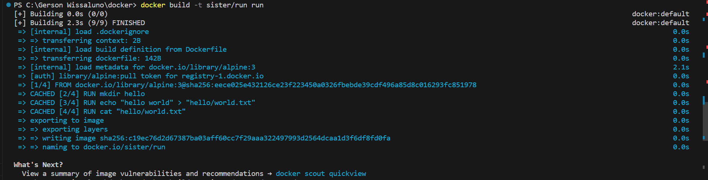

Kode Command Instruction

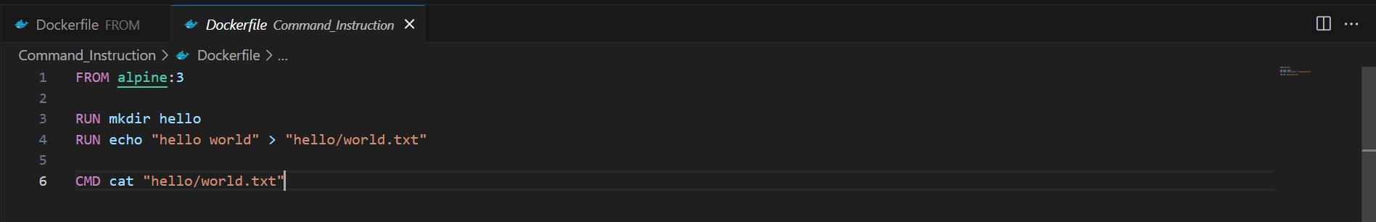

Kode : Docker Build



Kode Label Instruction

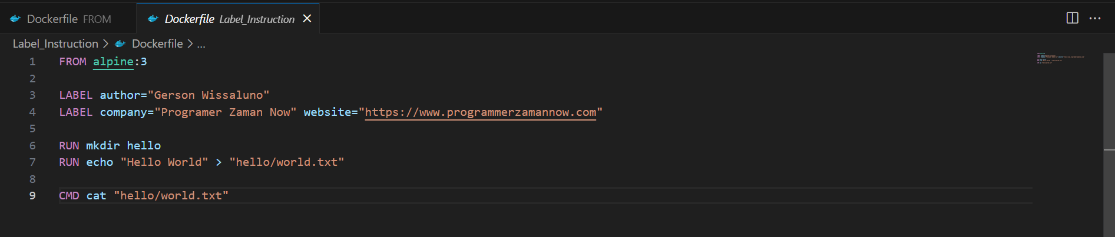

Kode : Docker Build

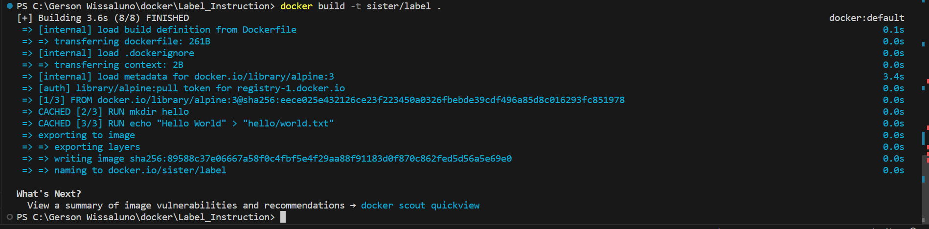

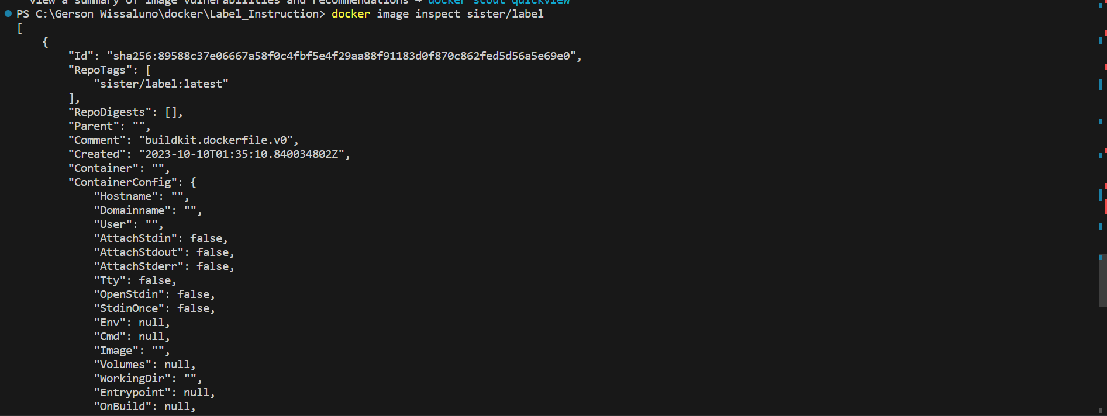

Kode Add Instruction

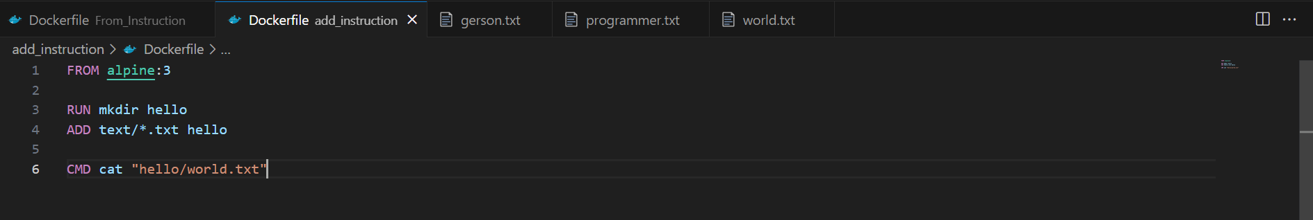

Kode : Docker Build

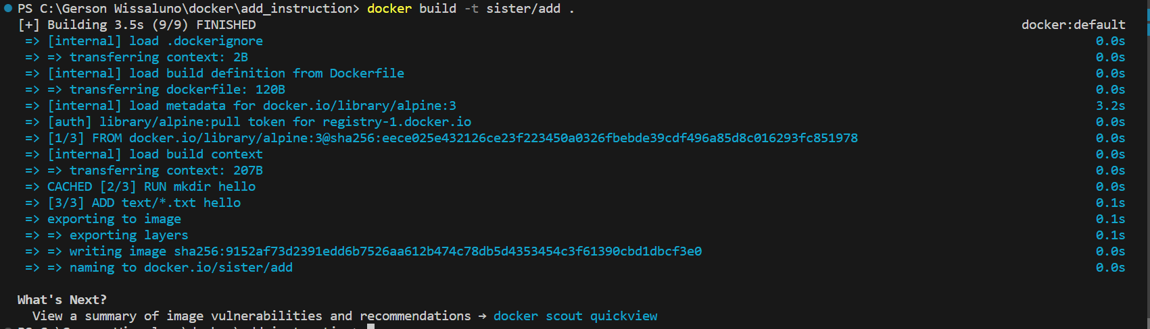

Kode Add Instruction

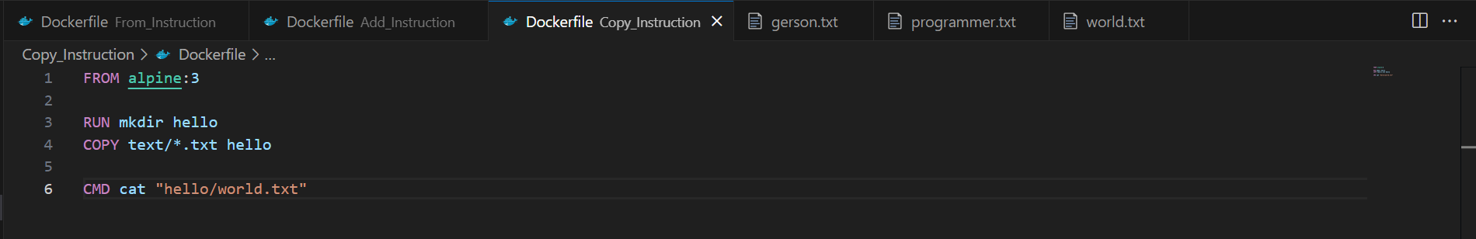

Kode : Docker Build

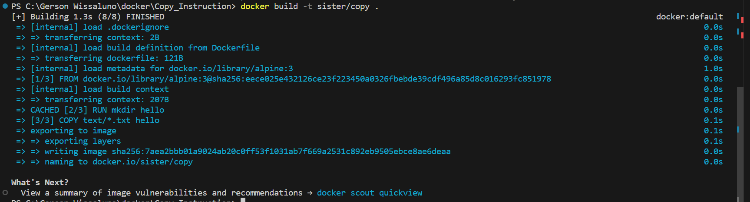

Kode DockerIgnore

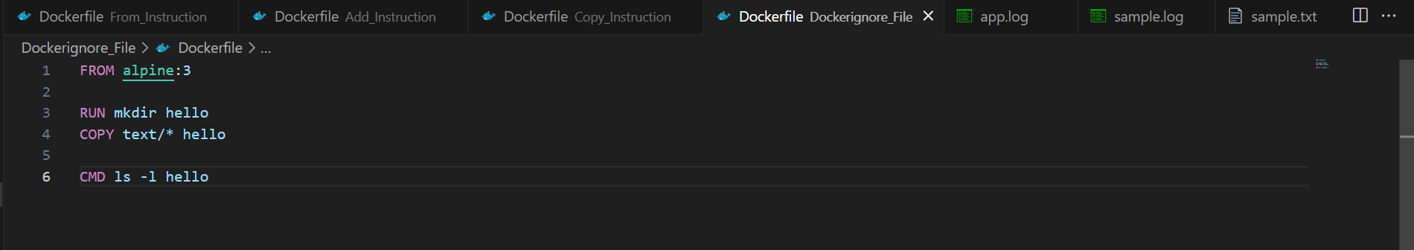

Kode : Docker Build

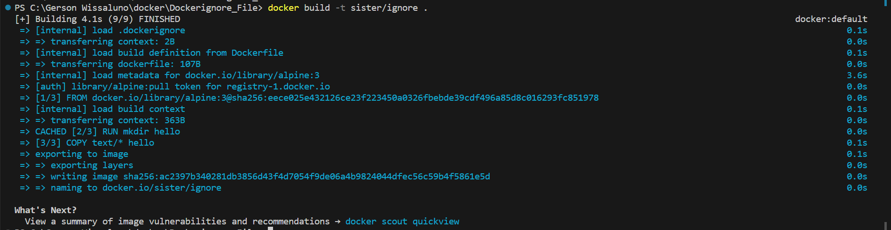

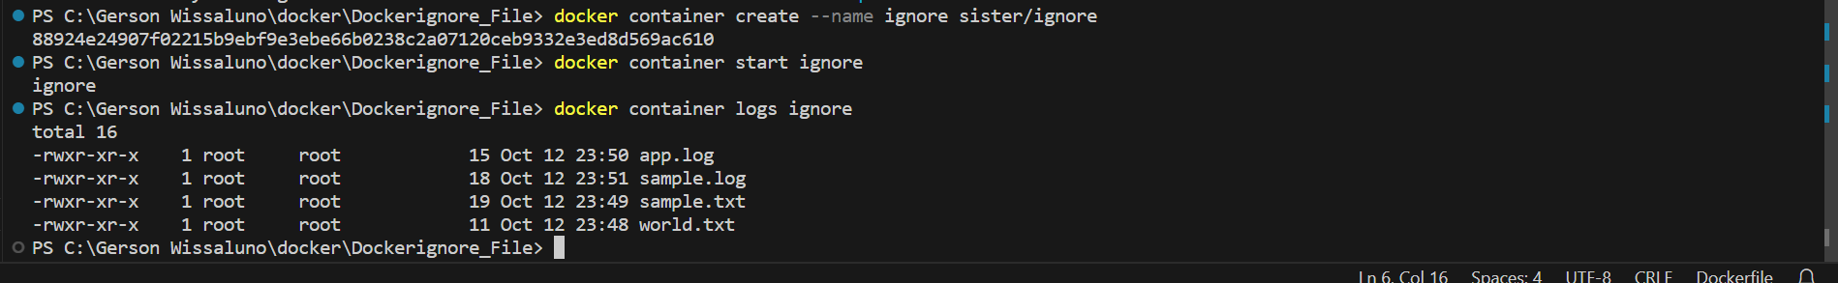

Kode Expose Instruction

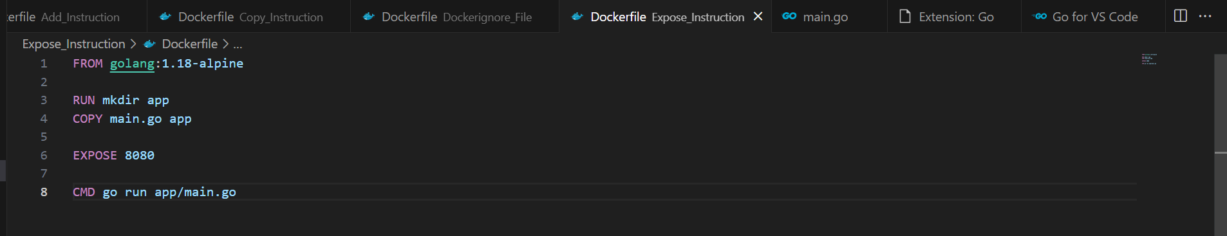

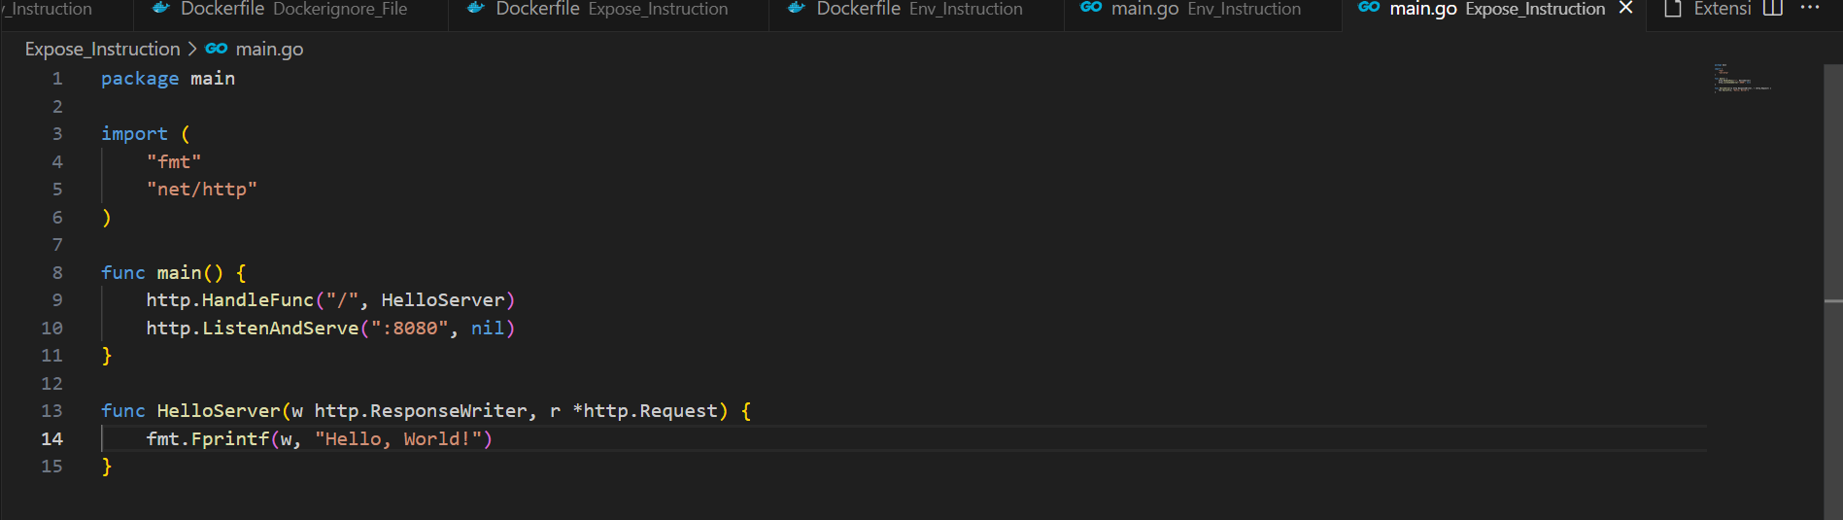

Kode : Docker Build

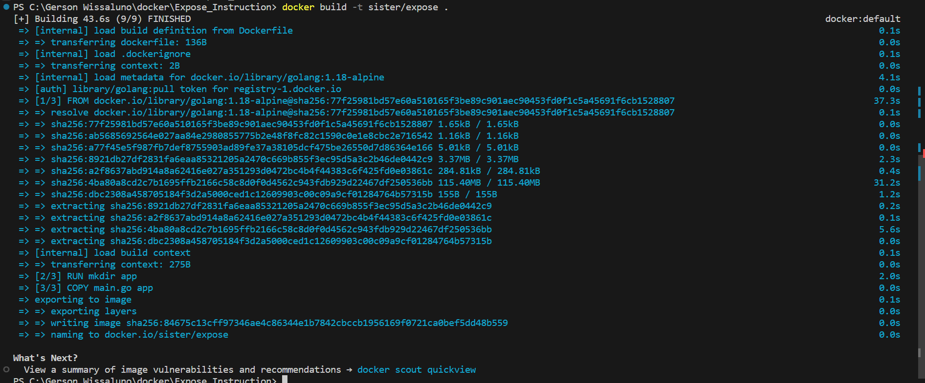

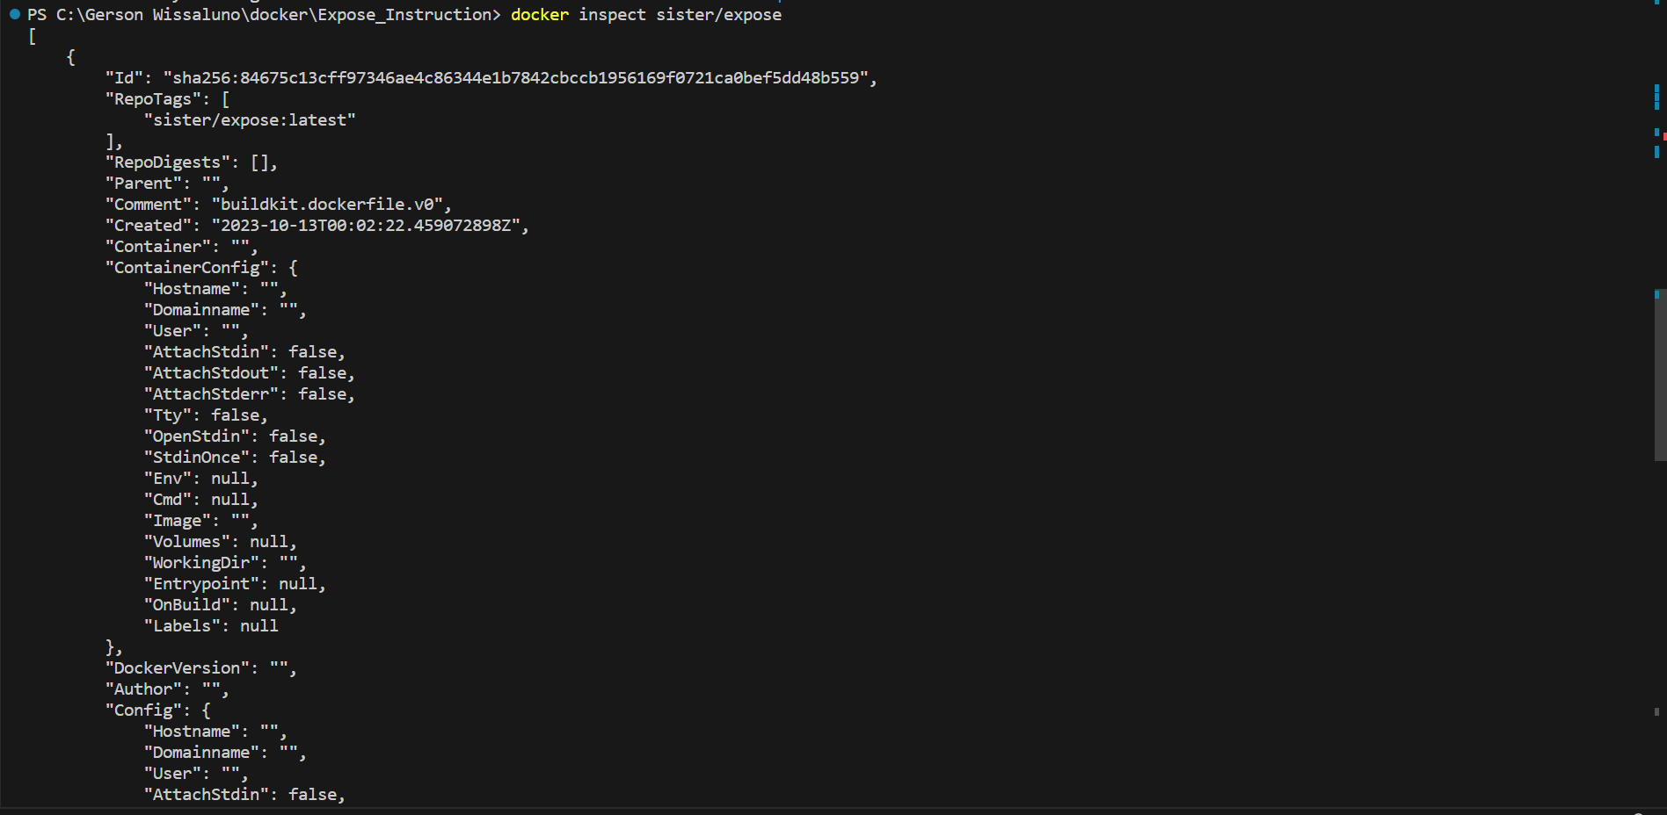

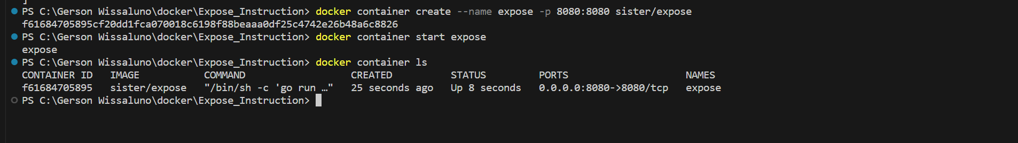

Kode Environment Variabel Instruction

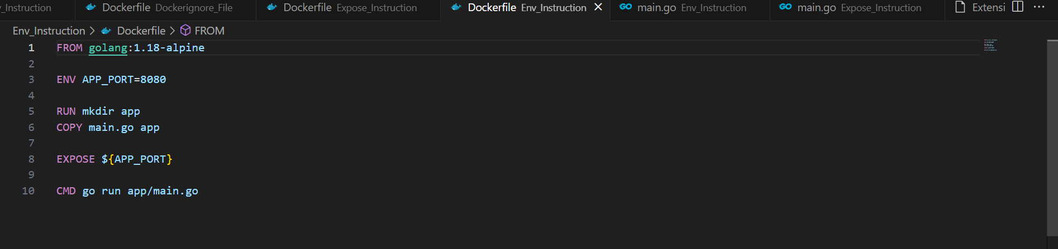

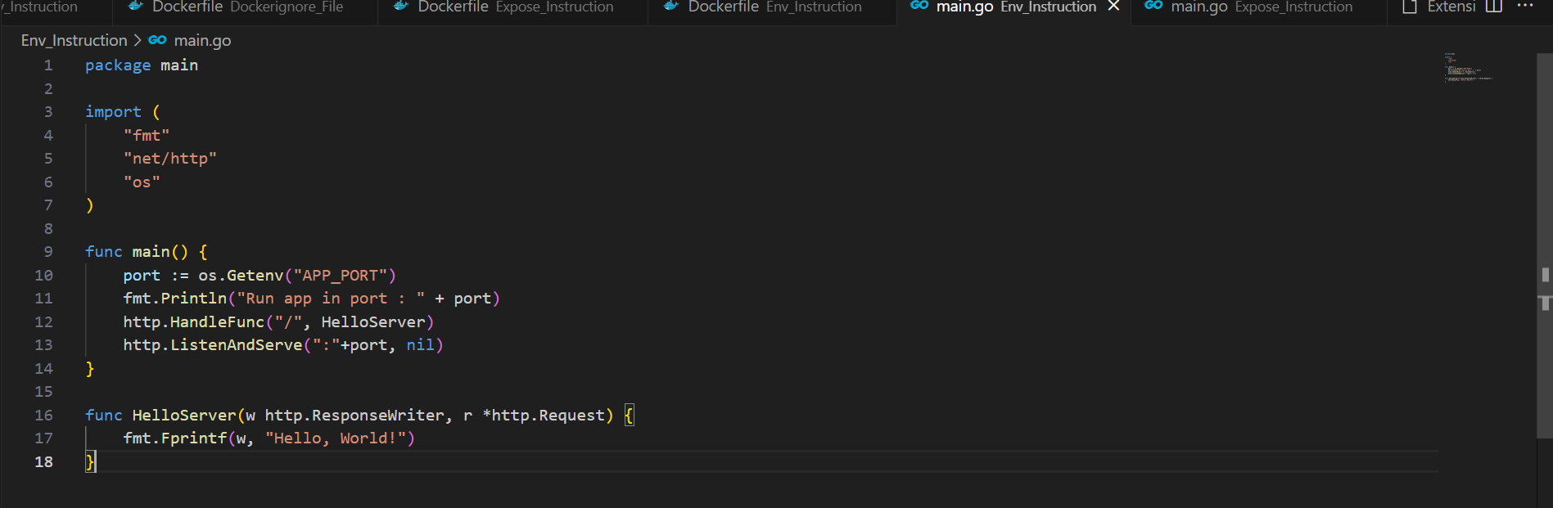

Kode : Docker Build

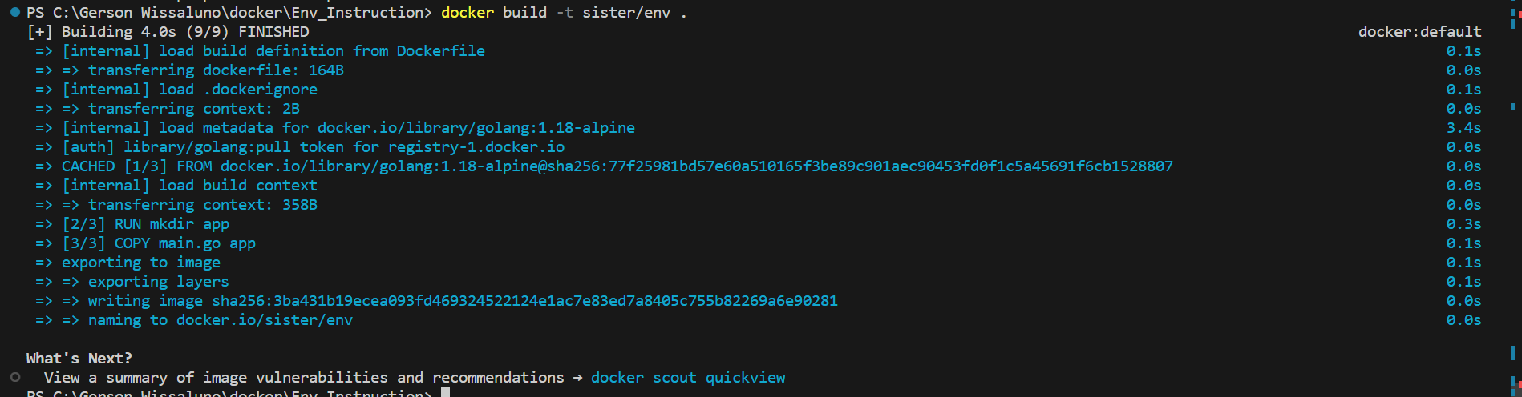

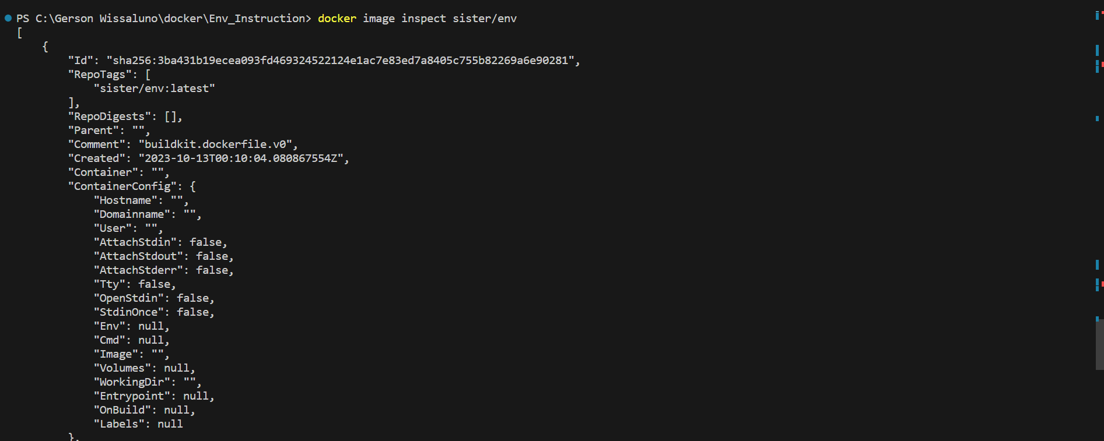

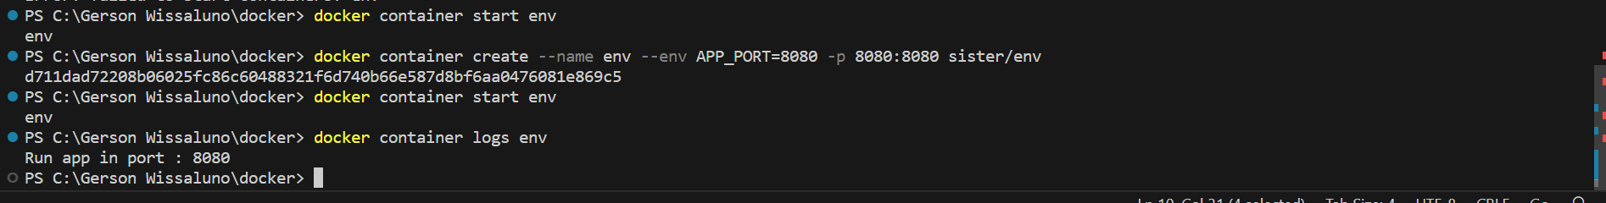

Kode Volume Instruction

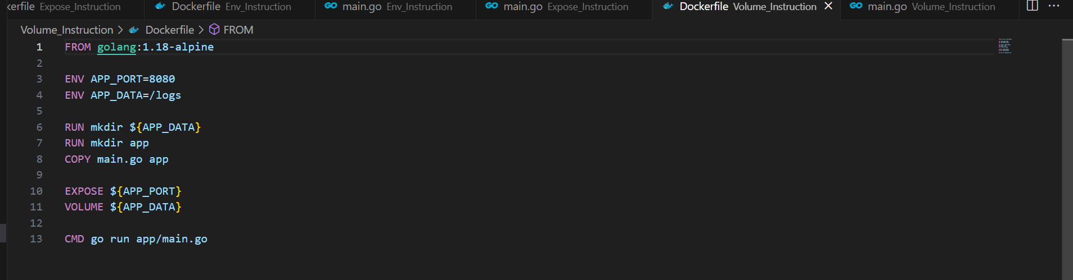

Kode : Docker Build

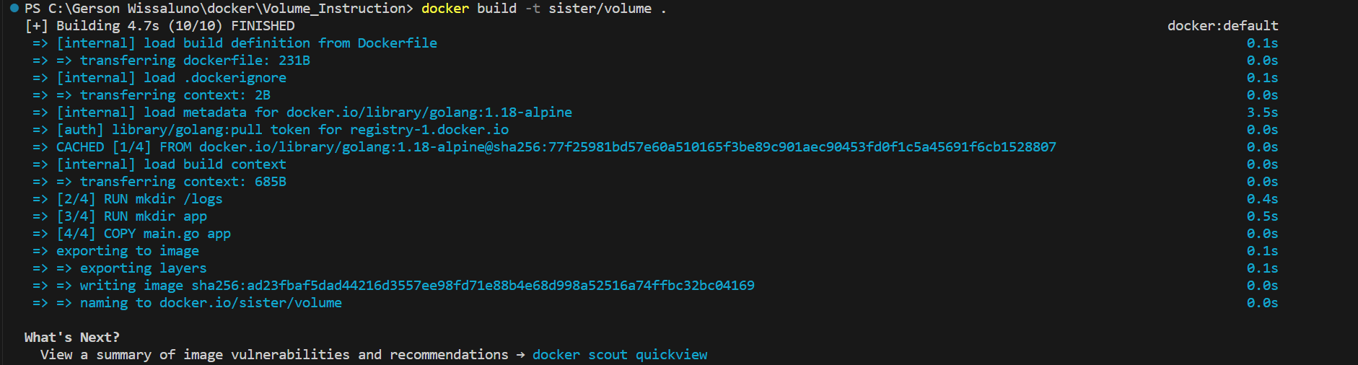

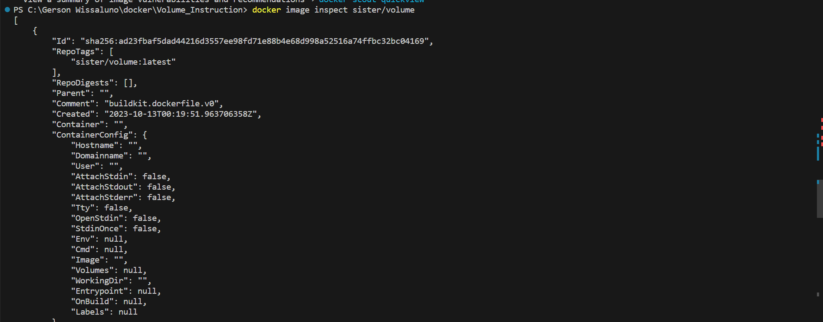

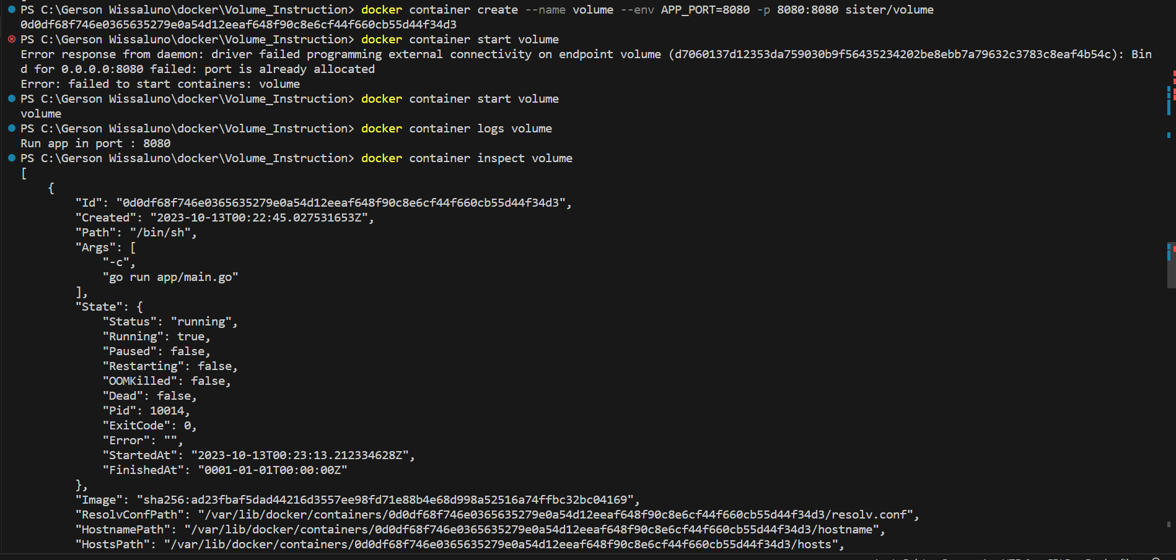



Kode Working Directory Instrcution

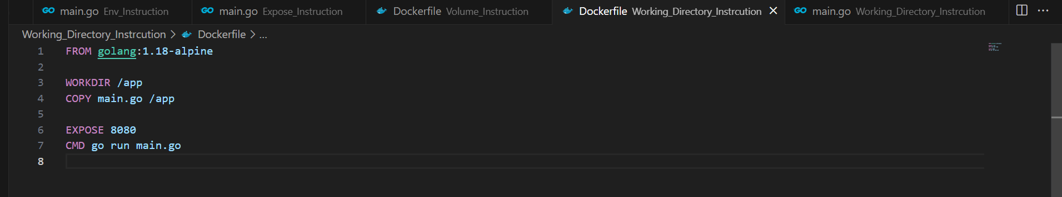

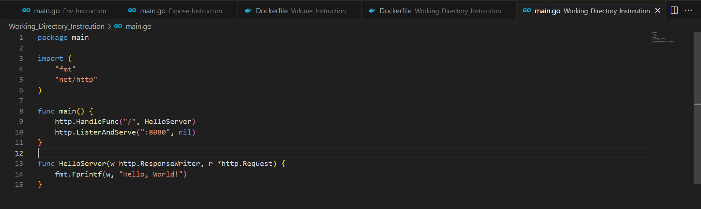

Kode : Docker Build

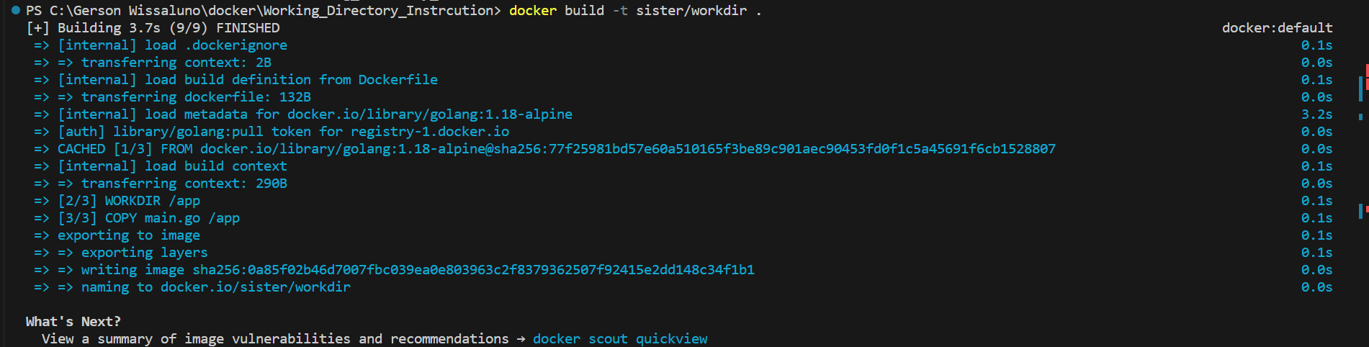

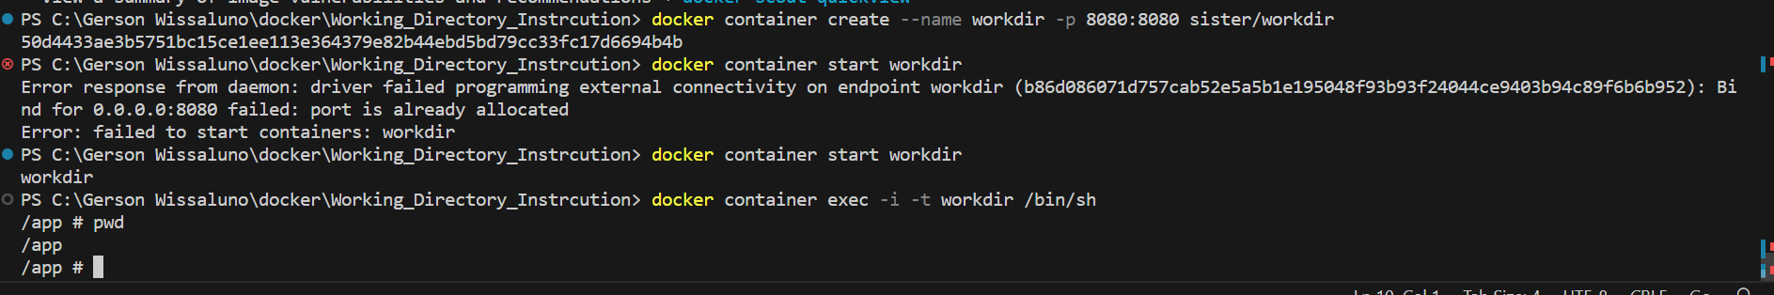

Kode User Instrcution

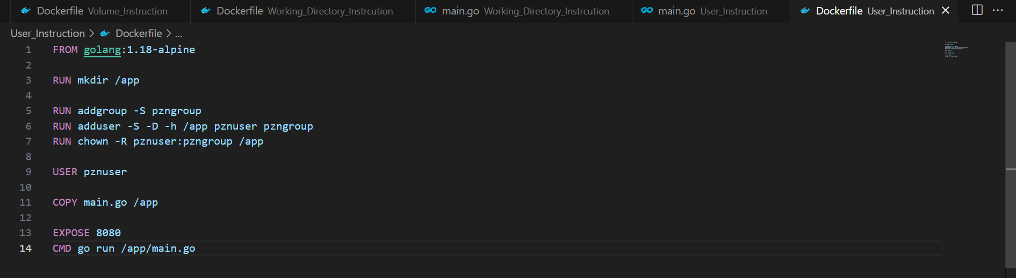

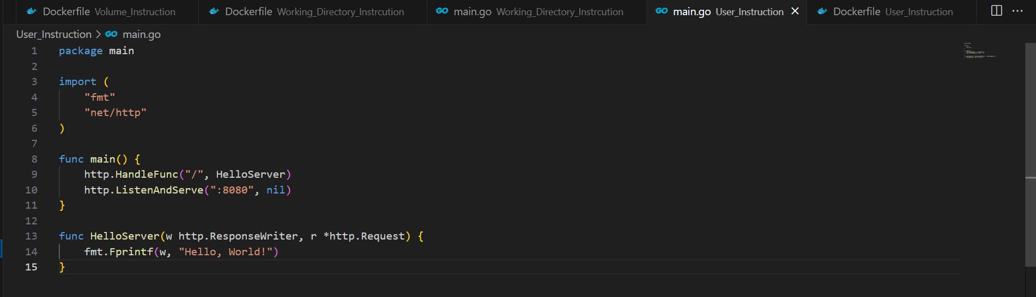

Kode : Docker Build

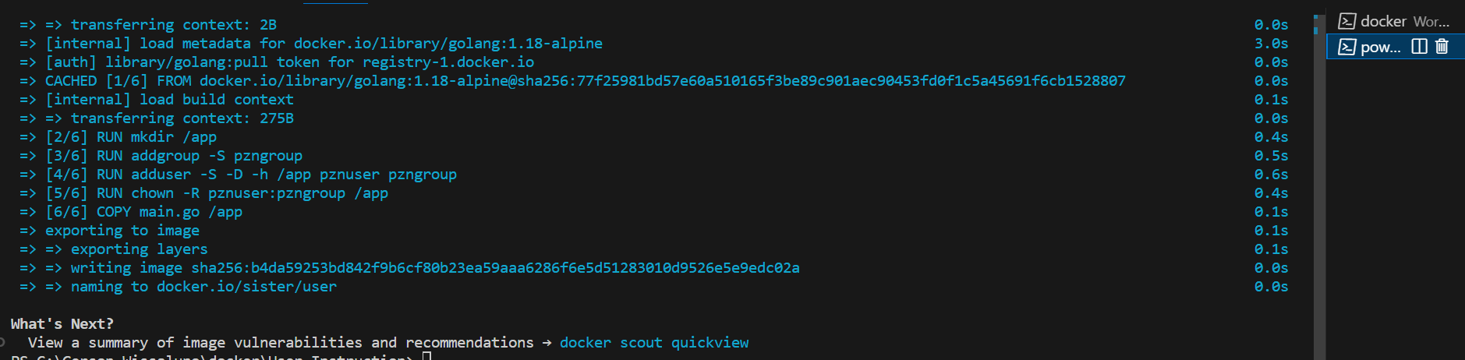

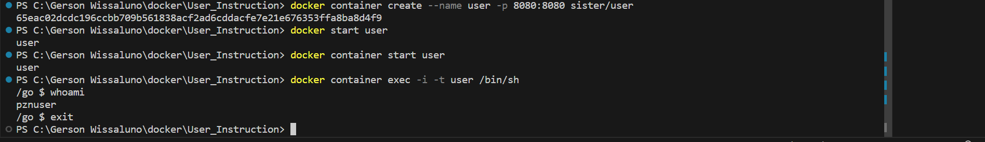

Images

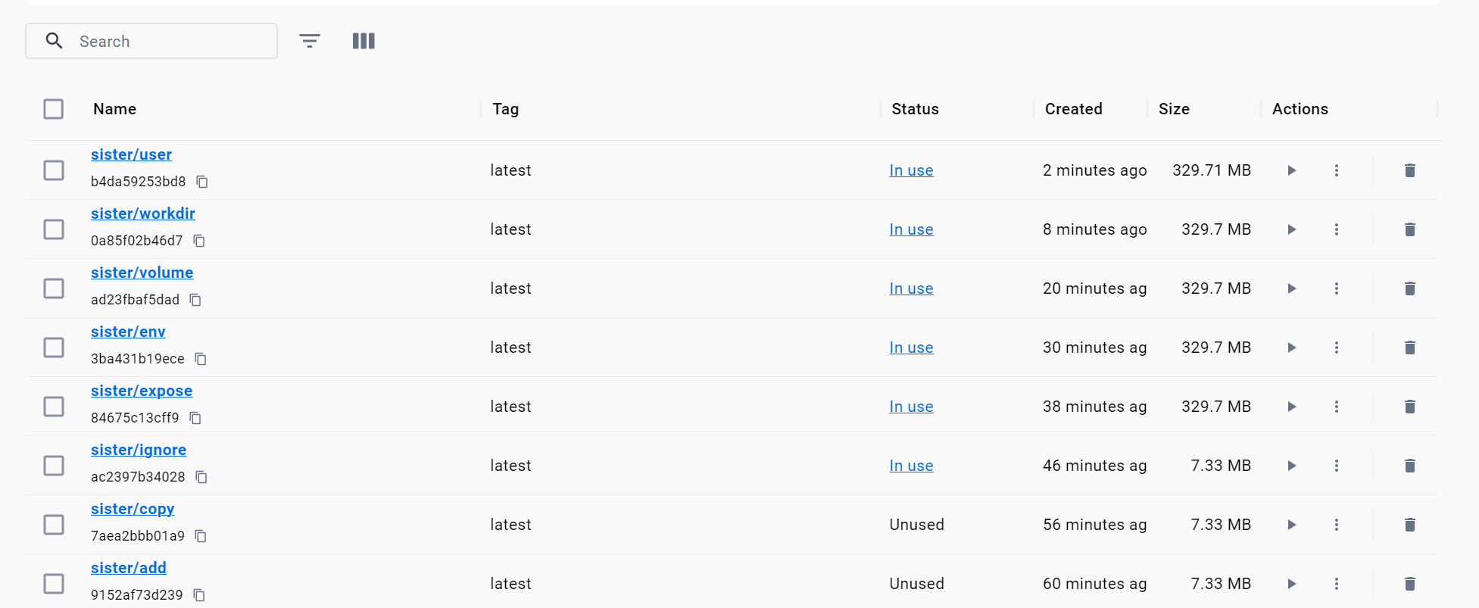

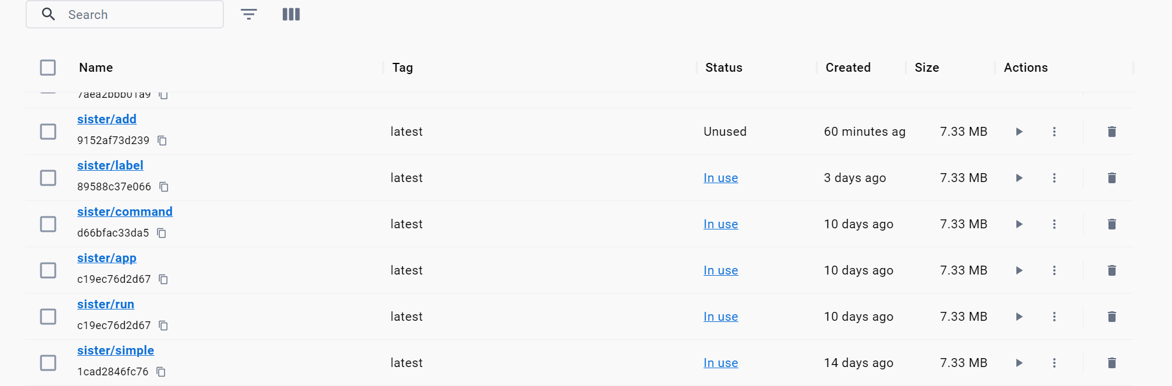

Containers

